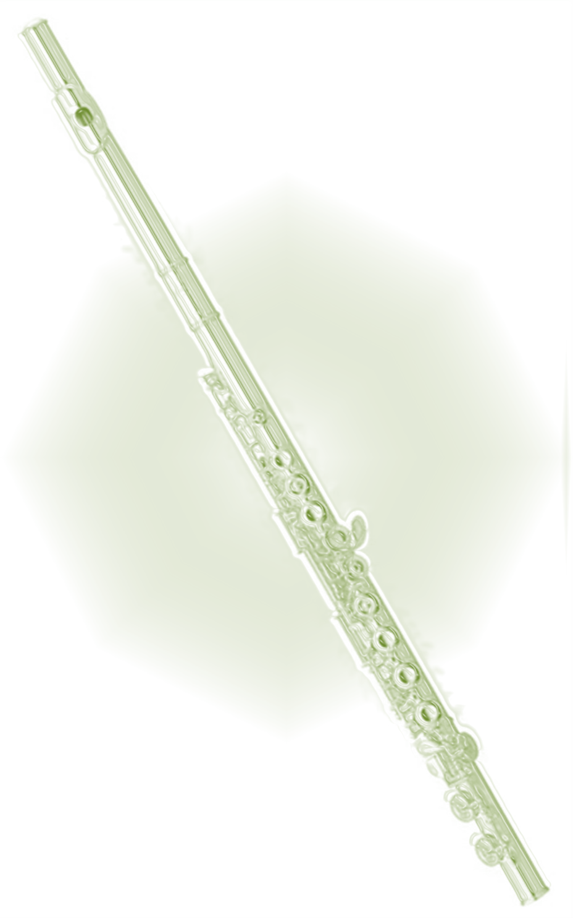
The Forest Flute Choir
Flute Workshop
For beginners, returners, or those who are just plain rusty!

Sunday 19th April 2015
2pm-5pm
Parkend Memorial Hall, Parkend,
Forest of Dean, Glos.
The afternoon is designed especially for those up to about grade 3 level. Everyone is welcome, regardless of age or experience- but you must be able to read and play at least 5 notes (F, G, A, B [B flat] and C). You need to bring your own flute and music stand if you have one. This cost is just £5 for everyone, inclusive of afternoon tea.
For further information www.forestflutechoir.co.uk or call 01594 563079

